[Note to Instructor: We recommend that you read through this PowerPoint (especially the notes section) to help you get a feel for the presentation. Feel free to modify it to better fit your needs. Some slides will begin with brief Talking Reminders that may help you remember during the presentation what should be discussed while viewing the slide. We’ve also provided a Full Script that you could read aloud if preferable. Please note that in the Full Script, anything written in italics is not to be said to your audience but is for your information.]
Slide | Talking Reminders | Full Script
Slide 0: Introduction to Community-Focused Exposure and Risk Screening Tool (C-FERST)  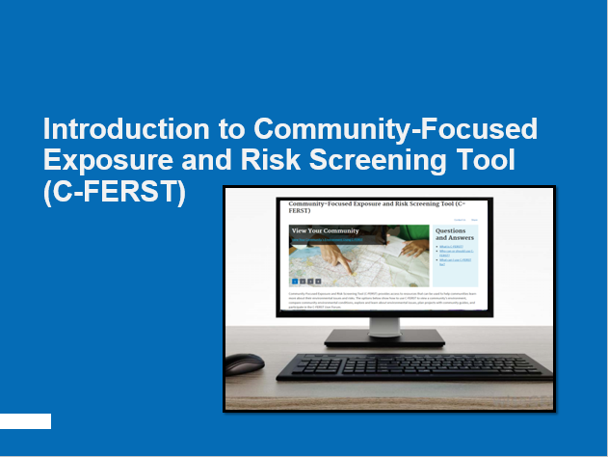 | Welcome & Instructor Introduction | Hello, and thank you for joining today’s training on the EPA’s new Community-Focused Exposure and Risk Screening Tool, or C-FERST for short.  My (Our) name is ______________ , and I (we) will be leading the training today.  [Feel free to give a little background on your experience with C-FERST].
Slide 1: Module 1: Course Description | What, Why, Who, and How. | Today, we will discuss C-FERST:  including what the tool is,  why you’d want to use it,  who should use it,  and how to use it.
Slide 2: Agenda  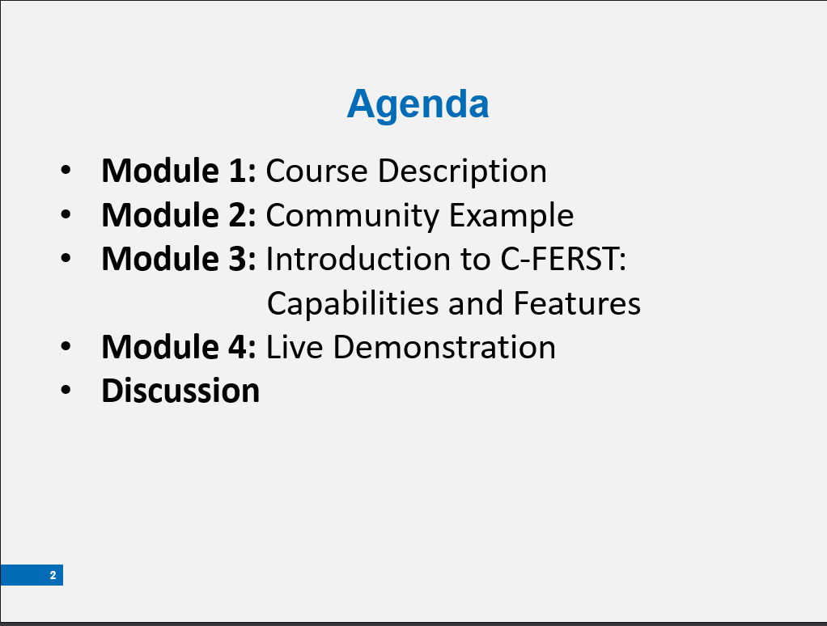 | 4 Modules  Live Demo  Discussion: how you can become a trainer  (if you previously received an example community from a participant)  Thank-you to _____________ (participant) | The presentation includes four modules. We are halfway through Module 1! In Module 2, we will highlight how C-FERST has been used in a community. In Module 3, we will introduce C-FERST’s capabilities and discuss the tool’s features.  Module 4 is a Live Demonstration. Here, we will walk through a community example to show you how to use the tool. [Only read the next sentence if your participants will be following along with their own computers]: Not only will we show you how to use C-FERST, but you also will be able to use the tool itself by following along on your own computer.  OPTIONAL: [If you will be demonstrating a participant’s community in the demo portion, take this time to thank them for responding]  Prior to the presentation, I emailed all participants asking if they have a community with specific needs that they would like to have demonstrated during the Module 4. I would like to thank [Participant] for volunteering their community, [community name] to be featured in a live demonstration.  After the Demo, we will discuss presenting C-FERST to Communities. We will cover how to plan and present a C-FERST demonstration and offer some tips on how to communicate effectively with communities.
Slide 3: Question Time! | 1. Have you ever used C-FERST?  2. What are you hoping to get out of the training today?  Thanks! | Before we get started, I’d like to get a little more background from everyone participating today by asking a few questions. These help me cater to the audience!  [For webinars: In some programs, like Adobe Connect, you can create poll questions before the presentation. We encourage you to make the questions above and use this slide to poll the remote audience.]  Question Number One: Have you ever used C-FERST?  [Answer options: Yes, No, IDK]  [Give participants a few seconds to respond, then comment on their answers as appropriate.]  Question Number Two: What are you hoping to get out of the training today?  [Give participants a few seconds to respond, then comment on their answers as appropriate.]  Thank you for responding to these questions.
Slide 4: Goals  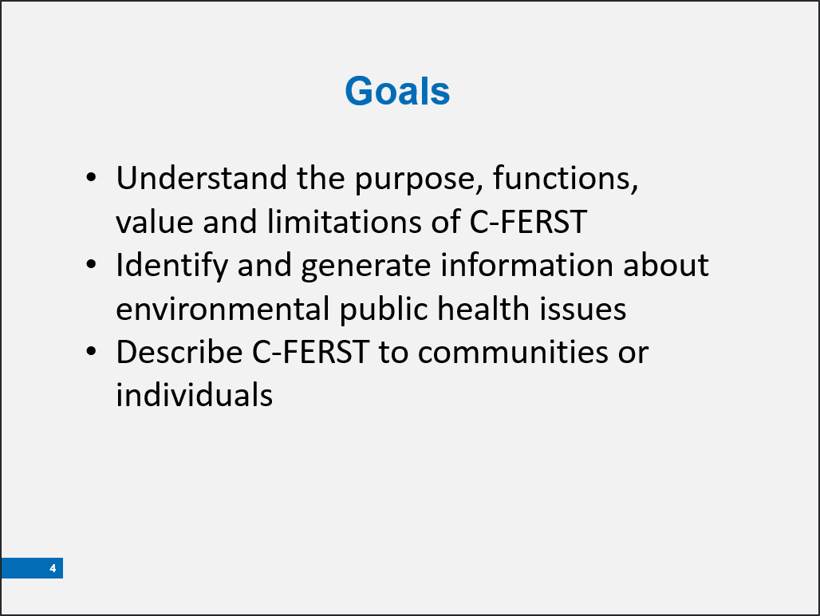 | C-FERST- how it works & how to explain it  You can become a “Trainer” & use these materials! | At the end of today’s course, you will be able to:  - Understand the purpose, functions, value, and limitations of C-FERST.  - Use C-FERST to identify and generate information about environmental public health issues in a community.  - Describe C-FERST functions to communities/individuals.
Slide 5: C-FERST is  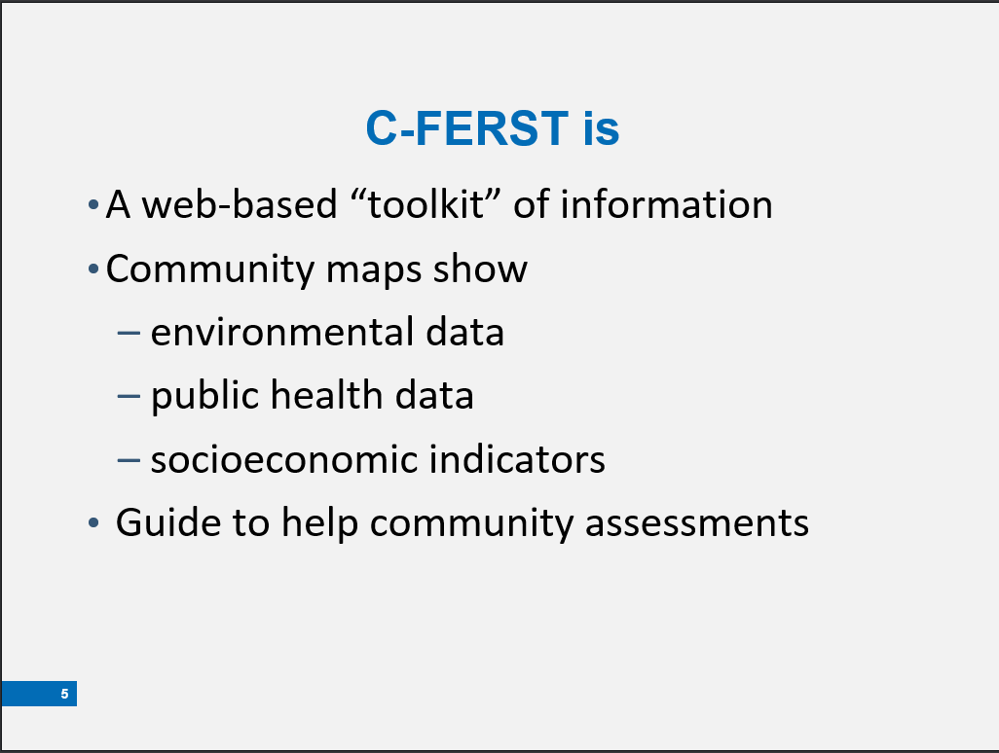 | Screening tool  Data  Guides | As an online screening tool, C-FERST focuses on Data and Information Access – it gives access to peer reviewed, scientifically sound:  - Environmental Data  - Health Data  - Socioeconomic Data  To assist with screening place-based community environmental public health issues at the census tract level of detail. [Census tracts are population-based, so rural areas have larger census tracts than urban areas where people live closer together.]
Slide 6: Why C-FERST Was Created  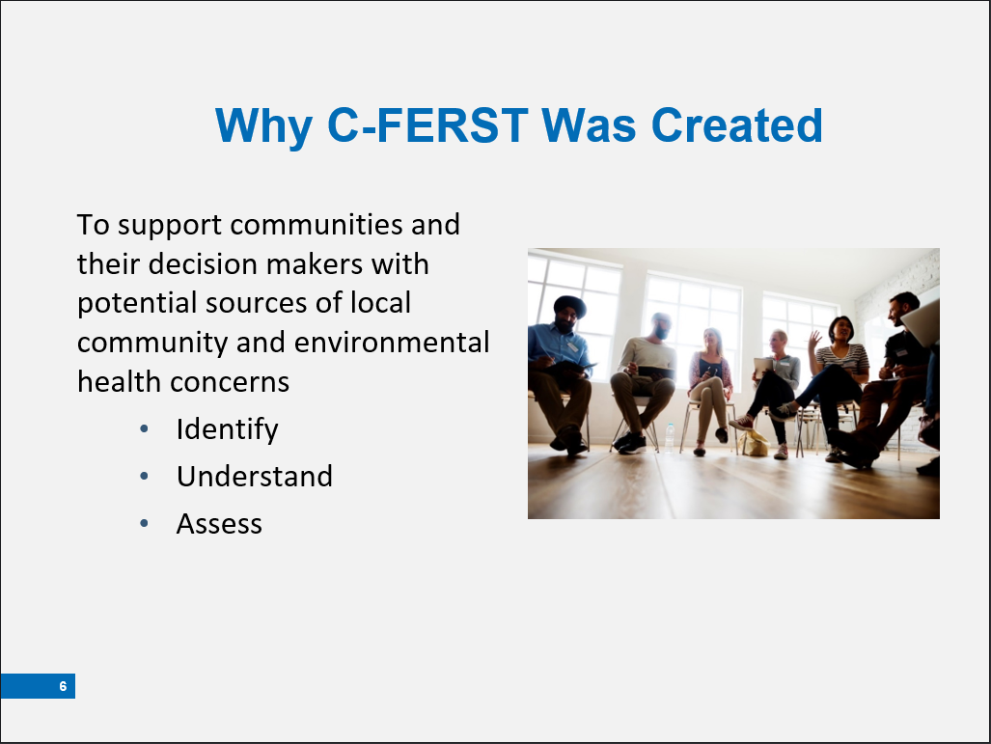 | C-FERST: EPA information and data accessible to American public | C-FERST was created to make important EPA data available in an easy-to-access format for American communities. Using C-FERST, every community can look at their concerns in various ways. This screening tool may help show where more data could be collected.
Slide 7: What can you do with C-FERST?  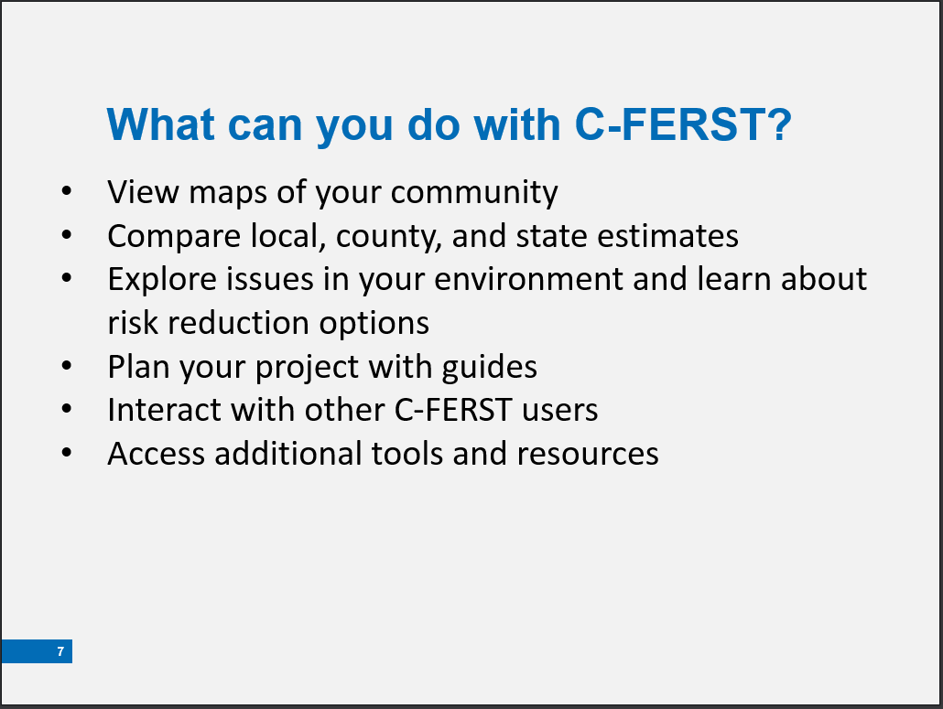 |  | View maps of your community  C-FERST maps contain information on pollution sources, estimated concentrations, exposures and risks for select pollutants, demographic data, and other key community characteristics.  Compare local, county and state estimates  C-FERST’s “Community Data Table” provides a summary of environmental conditions for a community, including estimated concentrations, exposures and risks for select pollutants, as well as demographic information.  Explore and learn about issues in your environment  C-FERST’s “Environmental Issue Profiles” contain links and information from various EPA and non-EPA sources for issues and concerns commonly identified by communities. C-FERST contains hotlinks to exposure and risk reduction options, and projects implemented by other communities  Find additional resources  C-FERST’s “Additional Tools” link contains a searchable list of tools available for conducting community exposure and cumulative risk assessments. The “Environmental Measurement Methods” section in C-FERST provides links to key EPA resources related to citizen science air monitoring and other available measurement methods.  Follow walk-through guides for conducting community assessments:  Community guides in C-FERST can provide information to help community groups systematically conduct an environmental health assessment in their locality. Guides in C-FERST include: EPA’s Community Action for a Renewed Environment (CARE) Roadmap; and the National Association of City and County Health Officials’ Protocol for Assessing Community Excellence in Environmental Health (PACE-EH).  Interact with other C-FERST users  C-FERST contains a forum for users to ask questions, provide comments, and share stories about their experiences using C-FERST.
Slide 8: C-FERST Can Be Used By:  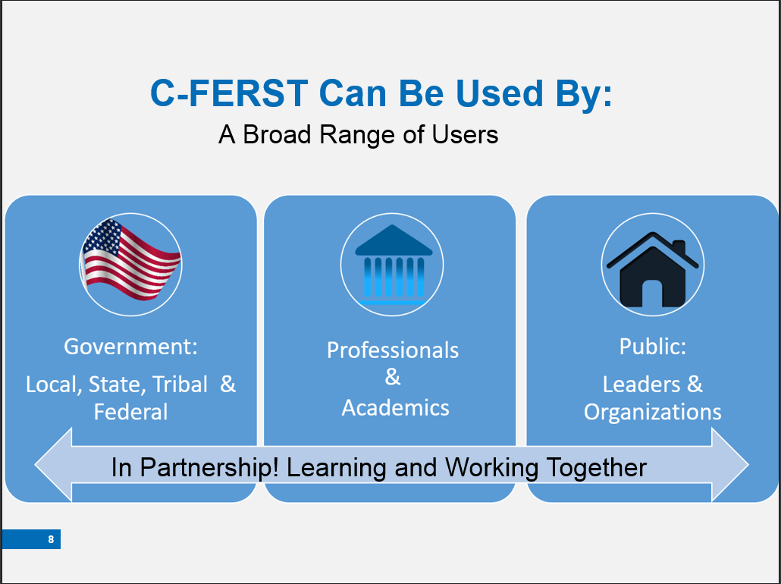 | Anyone, really! (with a computer) | C-FERST can be used by anyone with a computer and Internet access.  Anyone can use C-FERST, however, it may be mutually beneficial for community members and groups to work with regional, state or local environmental experts to identify and evaluate issues, and interpret C-FERST data and results. Communities can bring local insights to public health and risk assessment specialists.
Slide 9: Module 2: Community Example  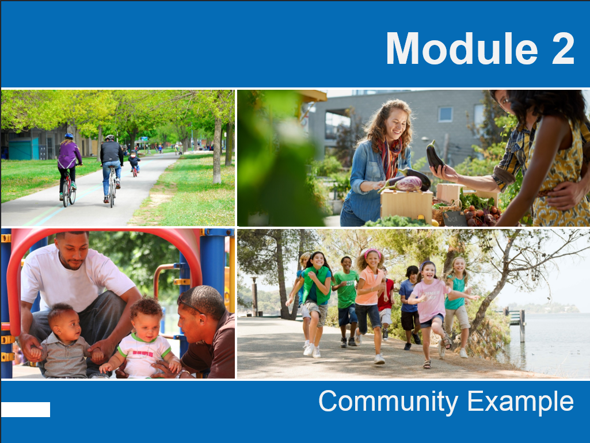 | C-FERST In Use | What can this tool do for you? Let’s start with an example of how C-FERST has been used.  [based on a true story]
Slide 10: Example: Service First University  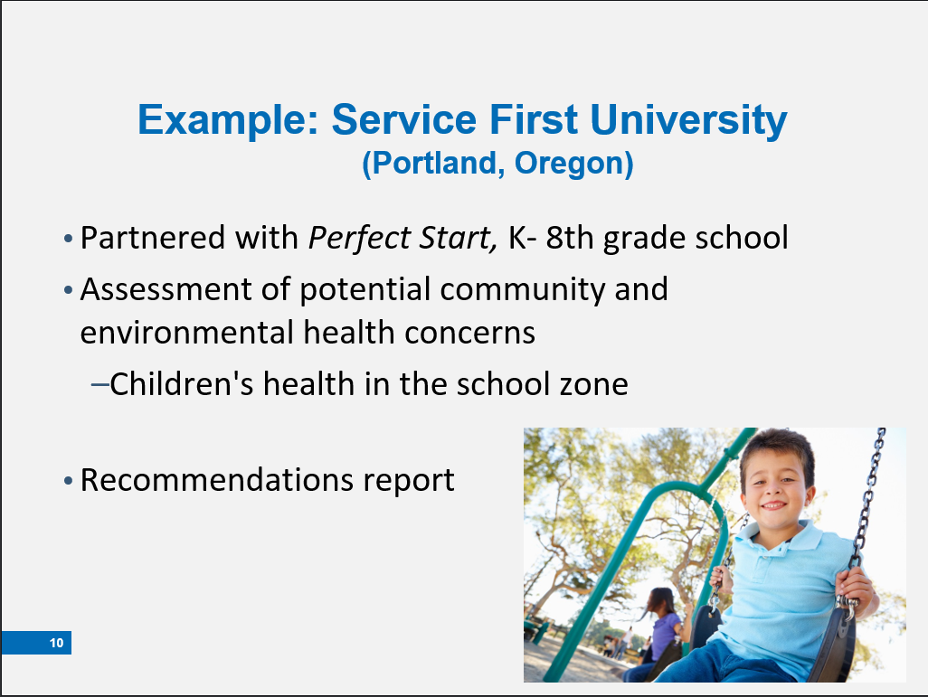 | Partnered with grade school  Social work students conduct assessment  Children’s health & the Environment | In this example, Service First University in Portland Oregon used C-FERST to look at children’s health and the environment.  This University believes in being active in its community. Near the University, a Pre-K through 8 school called Perfect Start was struggling. Because the University is committed to neighborhood involvement, service, and justice, they decided to partner with Perfect Start. As partners they hoped to help close the achievement gap.  The university asked social work students to conduct an assessment of community needs and concerns, focusing on children’s health and the environment within Perfect Start’s census tract.
Slide 11: Concerns  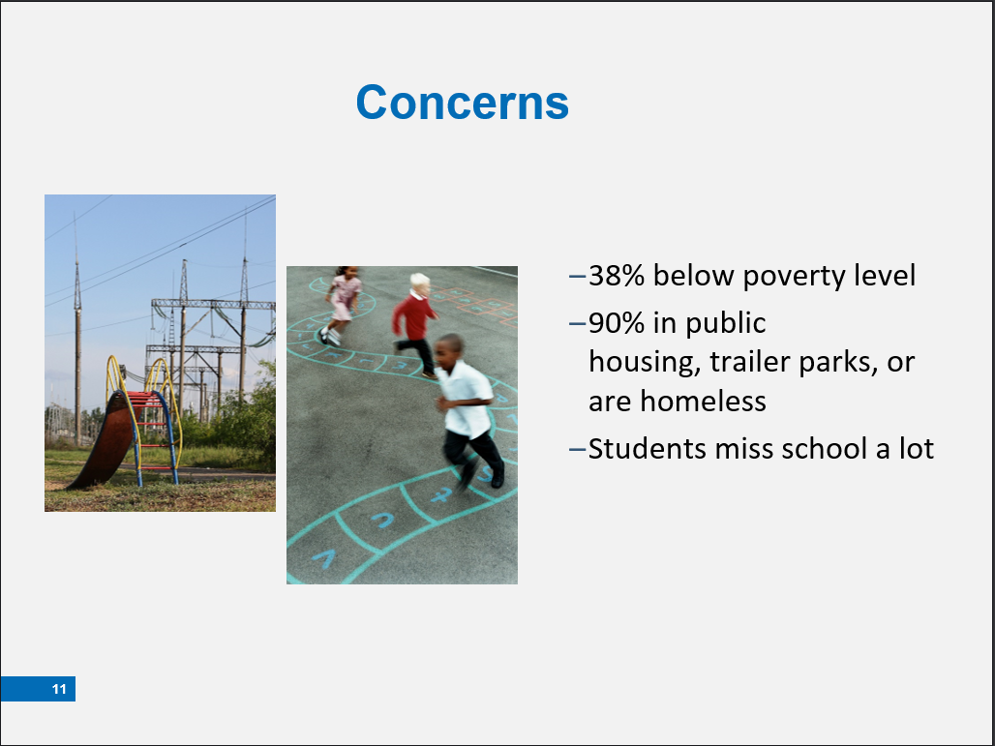 | Low income  Absent  Multiple environmental stressors may impact children’s health | Students were aware of a few issues in the Perfect Start school zone to begin their assessment. These issues included:  - 38 percent of residents live at or below the poverty level,  - 90 percent live in public housing or trailer parks (some are homeless),  - Students have high absenteeism.  Based on these facts, the students were concerned about how multiple stressors may impact children’s health and development. The students decided to use C-FERST as a resource for their assessment.
Slide 12: The CARE Roadmap  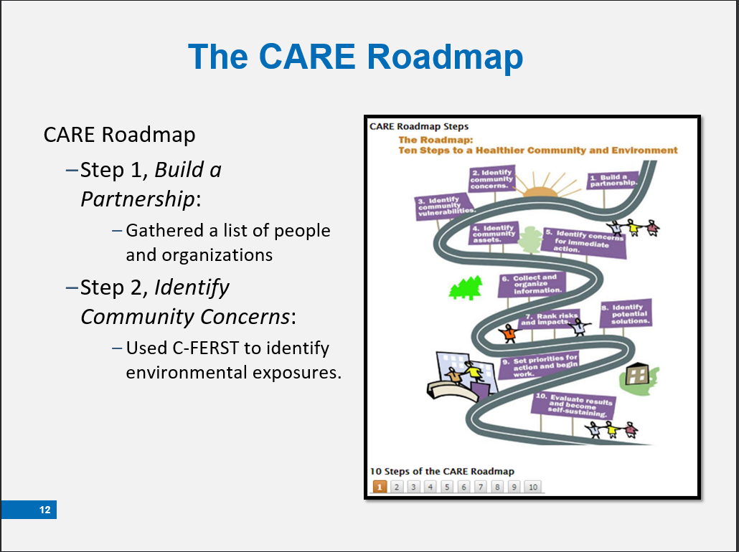 | Gathered People  Looked into their Environment using C-FERST | The students began with the C-FERST’s EPA CARE Roadmap to develop a plan and timeline for their assessment. They followed step one, ‘Build a Partnership’, and created a contact list of people and organizations who should be involved or consulted in the assessment.  The second step in the Roadmap, ‘Identify Community Concerns,’ led the students to use C-FERST to identify possible environmental risks in the study area.
Slide 13: Collect Data in C-FERST  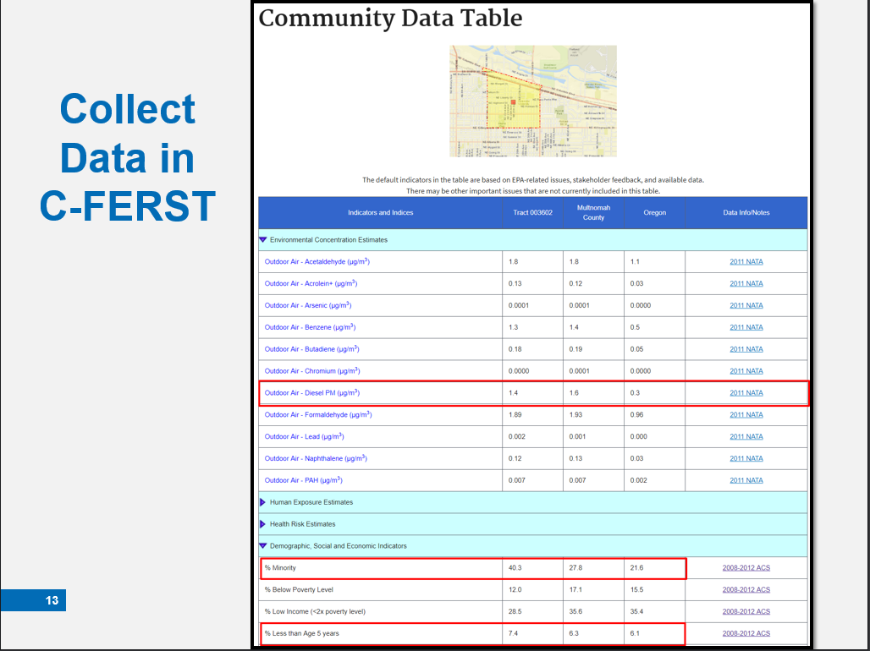 | Diesel PM levels are higher than the state  With a high % minority population and  Higher % young children | The students used the C-FERST Community Data Table to identify environmental risks and demographic characteristics for this area. They focused on community and environmental health indicators that were particularly high in their census tract such as air contaminants, minority and vulnerable populations including children.  [Use the cursor to highlight the key data on the Community Data Table.]  Where risks were disproportionately high, they followed the hyperlinks to learn more about specific issues.  [Hover the cursor over the Diesel PM as if you are clicking on that hyperlink.]
Slide 14: Narrow Research Focus  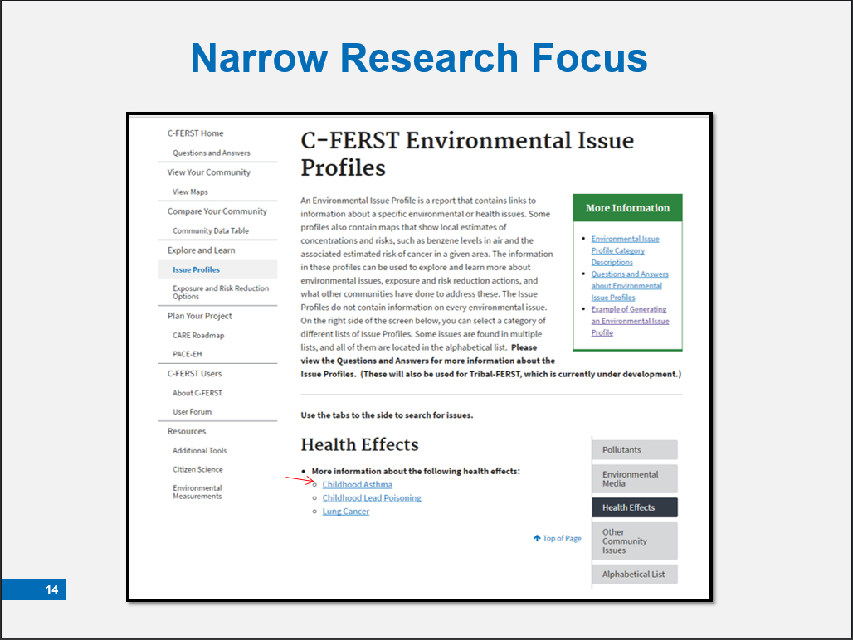 | Childhood Asthma  Indoor Air Quality (in School)  Diesel PM | The students also looked up information in issue profiles on childhood asthma and indoor air in schools before identifying Diesel PM as the contaminant they were most concerned about.
Slide 15: Create Maps to Visualize Environmental Concerns  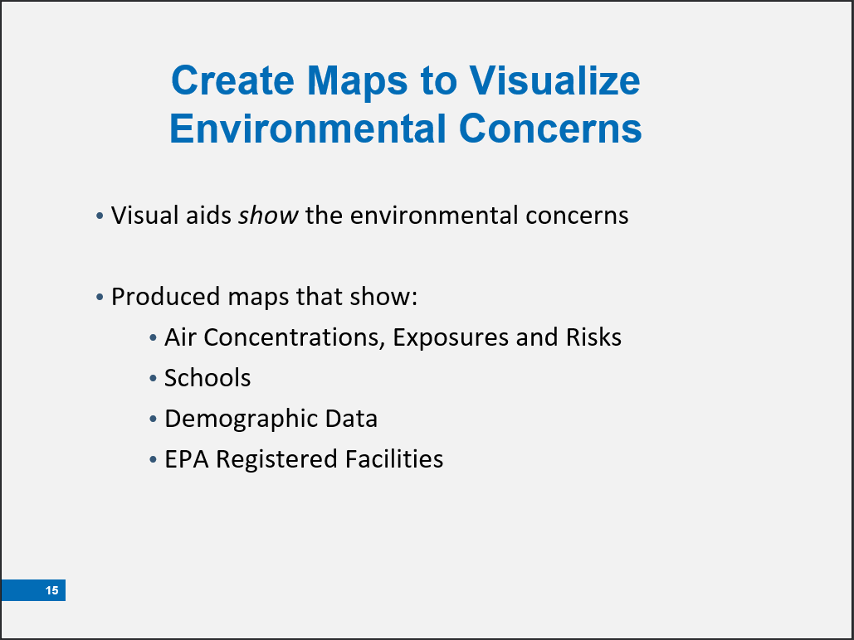 | What did they use Maps for? | C-FERST maps were used to create a visual aid to demonstrate the students’ findings. The map that I'm about to show you features the National Air Toxics Assessment (NATA) 2011 data, locations of Schools, demographic data, and EPA Registered Facilities.  [Advance slide to show map]
Slide 16: Example Map  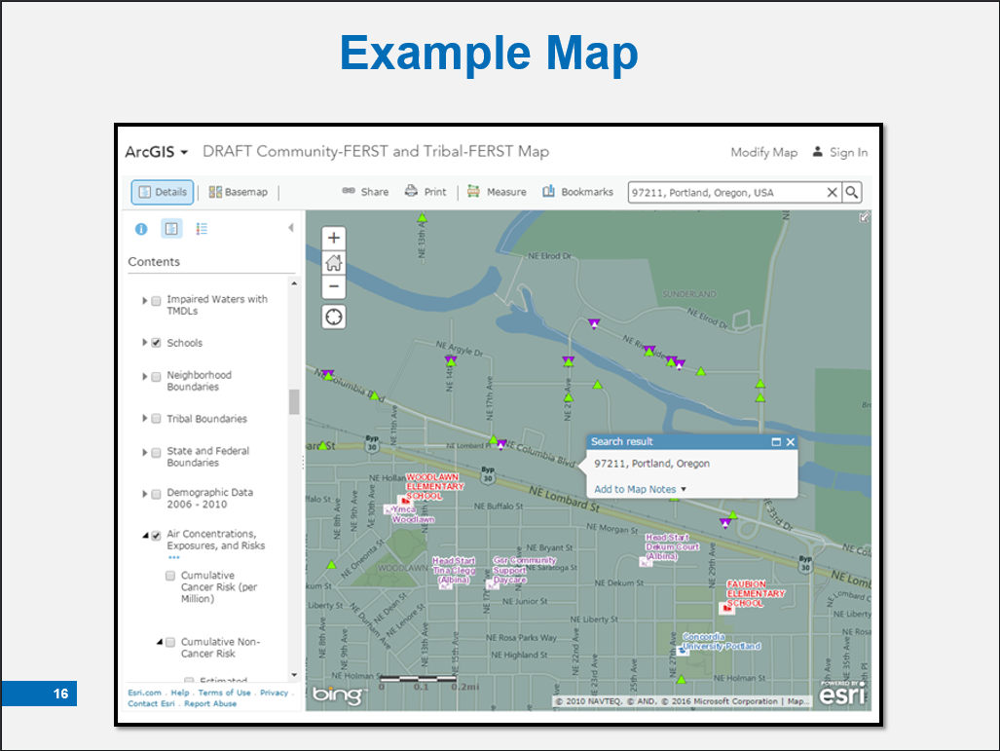 | Facilities of interest  Pop-ups | The students identified one EPA registered facility of interest, an Aerometric Information Retrieval System (AIRS) facility. Through C-FERST Map Pop-Ups, they accessed the Facility Registry Service (FRS) report, which included information for a contact that they could add to their Partnership list.  Next, they conducted a ground-truthing exercise to link the data collected in C-FERST with data collected in the field.  They followed the route children took to school and interviewed the K-8 school administration about reasons for the high absences. They learned:  - Students spent up to two hours going to and from school along a busy interstate.  - Many children miss school due to asthma  - Many students miss school due to unreliable transportation
Slide 17: Exposure and Risk Reduction Options for Childhood Asthma  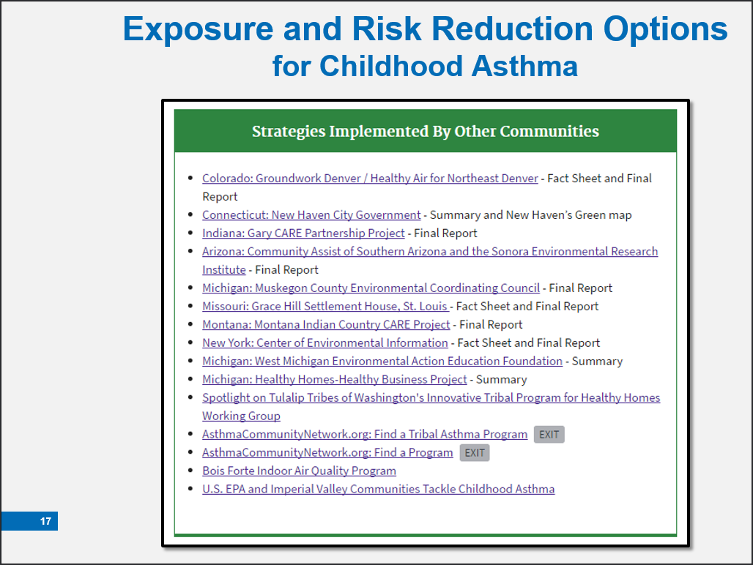 | How other communities responded to Childhood Asthma | Based on their research, the Social Work students were certain that air quality and children’s health are serious concerns in their community.  They wanted to know how other communities responded to this issue, so they consulted C-FERST to identify examples of community projects addressing air quality and children’s health. Students used these resources to develop recommendations for their report.  [Use the cursor to highlight the “strategies implemented by other communities” that the community could have investigated and mention this will be further explored during the demonstration in Module 4.]
Slide 18: Summary: Benefits  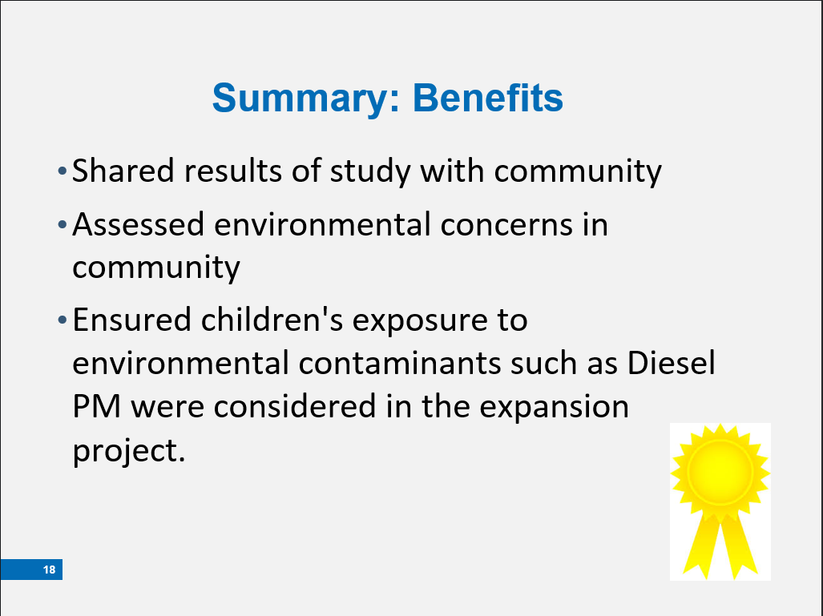 | Assessment helped  Partnership continues | Service First University invited the community to a presentation where the C-FERST assessment was shared with all affected partners and stakeholders, including local, state and federal partners.  The social work students were able to complete a thorough assessment of the Perfect Start school community. Science and community knowledge were used in tandem to identify, understand, and assess children’s health and the environment.  This assessment ultimately ensured that children’s health and environmental justice concerns such as disproportionate exposure to Diesel PM on school bus routes were considered as Service First University determined whether to expand its campus. The partners plan to continue the project to address environmental justice concerns in the Perfect Start Pre-K through 8 school area.
Slide 19: Module 3: Introduction to C-FERST: Capabilities and Features  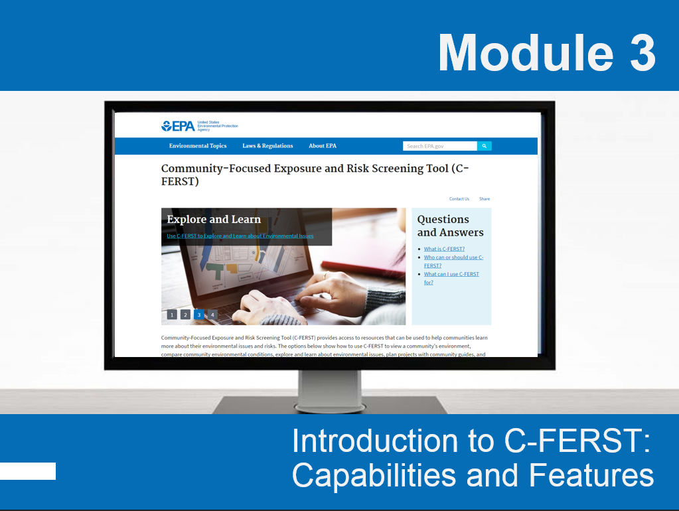 | Why, Where, When, and How of C-FERST.  Goal is for you to be able to describe C-FERST to others. | This module begins with a brief overview of the basics of C-FERST—the why, where, when, and how C-FERST should be used; who should use it; and its basic features.  At the end of this module, participants will be able to:  - Describe C-FERST’s basic features and its purpose.  - Describe the basic C-FERST functions.  - Understand the types of information C-FERST generates: environmental issue profiles, community data table, and maps.  - Explain limitations of C-FERST and the data it generates.
Slide 20: C-FERST's Main Sections  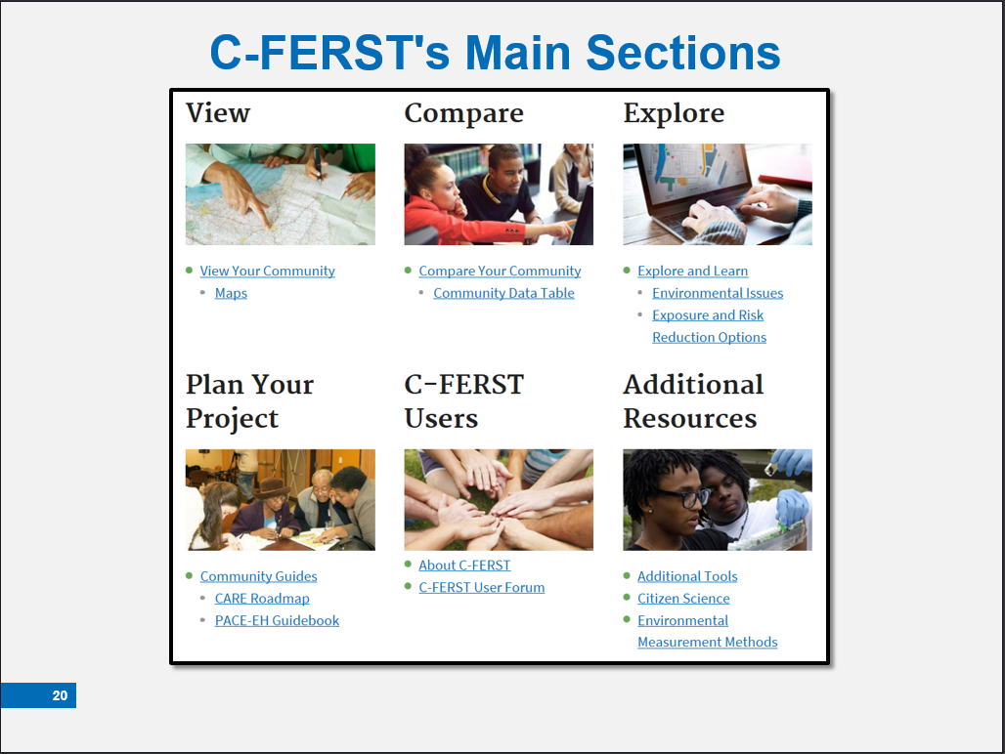 | 6 sections- maps, community data table, issue profiles, roadmaps, user info, resources | We’re now going to move on to the specific functions of C-FERST.  C-FERST is organized into six different sections.  [Advance slide: Click using mouse, arrow on keyboard or button on remote controller]  View – Contains Maps that allow users to see the different environmental and demographic information in a community.  [Advance slide: Click using mouse, arrow on keyboard or button on remote controller]  Compare – Contains a Community Data Table, which lists pollution levels for a specified community and compares it to the county and state levels  [Advance slide: Click using mouse, arrow on keyboard or button on remote controller]  Explore – Contains Environmental Issue Profiles which provide information on specific environmental issues. Each Issue Profile also contains Exposure and Risk Reduction Options to highlight what other communities have done.  [Advance slide: Click using mouse, arrow on keyboard or button on remote controller]  Community Guides - These Guides describe the steps needed to build partnerships, identify community concerns, learn about environmental issues, and identify actions to improve community health.  [Advance slide: Click using mouse, arrow on keyboard or button on remote controller]  C-FERST users – contains information about C-FERST and the User Forum  [Advance slide: Click using mouse, arrow on keyboard or button on remote controller]  Resources – Allows users to explore additional tools and resources that support C-FERST community assessment efforts
Slide 21: Community Guides: Overview  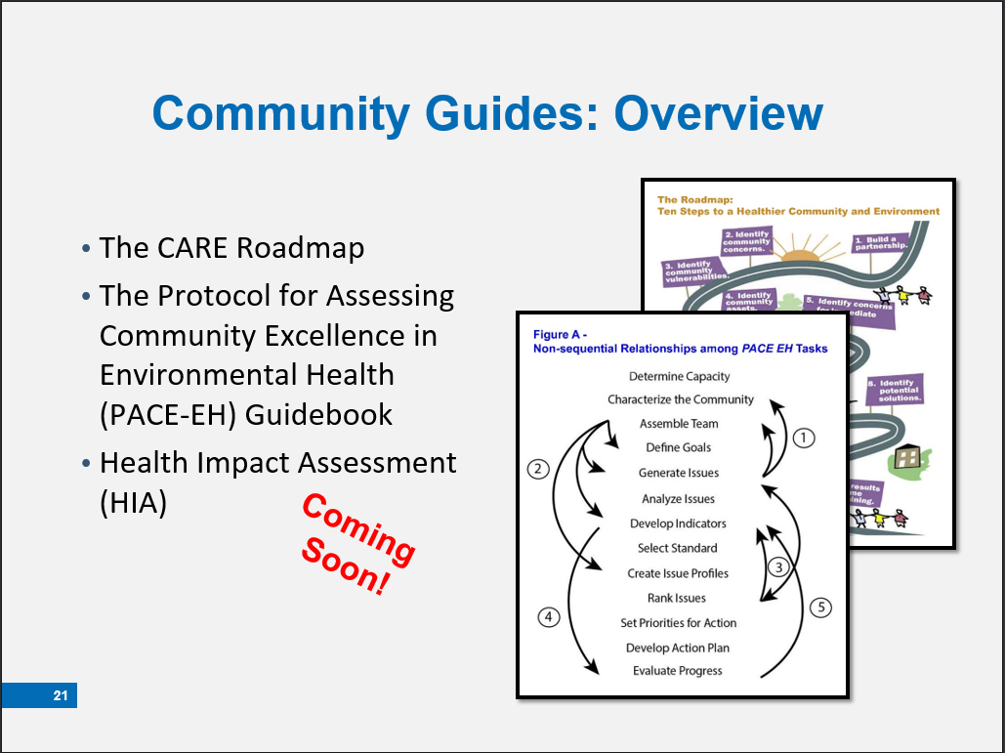 | Get Started with the Community Guides  These Frameworks lay out how to conduct a community assessment  3 options | Those new to C-FERST may find it beneficial to use the Community Guides to plan their community assessment!  C-FERST provides roadmaps that describe the steps to be taken to conduct a community assessment, including how to build partnerships, identify community concerns, learn about environmental issues, and identify actions to improve community health.  There are two guides currently featured in the Community Guides section: the CARE Roadmap and the Protocol for Assessing Community Excellence in Environmental Health (PACE-EH) Guidebook.  [Click the mouse once to have the CARE Roadmap bullet appear on the screen.]  The EPA CARE Resource Guide, developed by EPA's former Community Action for a Renewed Environment, or CARE program.  The EPA CARE Roadmap provides a structured process to:  - Learn about local environmental health risks and impacts  - Build the community consensus necessary to take effective action  - Mobilize a community partnership to take action to reduce impacts and risks  - Build long-term capacity within a community to understand and reduce environmental impacts and risks  Remember? The students at Service First University used the CARE Roadmap in their quest to identify environmental issues and identify possible solutions for the K – 8 school.  [Click the mouse once to have the Protocol for Assessing Community Excellence in Environmental Health bullet appear on the screen.]  The Protocol for Assessing Community Excellence in Environmental Health (PACE-EH) Guidebook is designed to help communities systematically conduct and act on an assessment of environmental health status in their localities.  The 13 step PACE-EH Roadmap was created by the National Association for City and County Health Organization (NACCHO).  This guide walks the user through a community-based process for:  - Characterizing and evaluating local environmental health conditions and concerns  - Identifying populations at risk of exposure to environmental hazards  - Identifying and collecting meaningful health data  - Setting priorities for local action to address environmental health problems.  Many CARE grantees have used the PACE-EH Guidebook to assist with community assessment, along with the CARE Roadmap and the CARE Resource Guide.  [Click the mouse once to have the Health Impact Assessment (HIA) bullet appear on the screen.]  The Health Impact Assessment guide is coming soon.
Slide 22: View  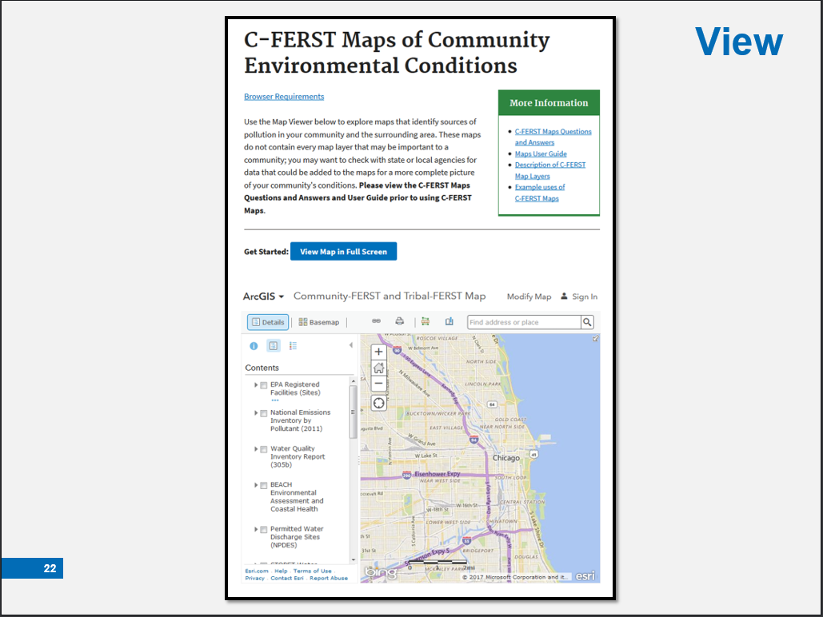 | Map layers- exposures & risks, locations of facilities, demographics  More in the future | This section contains maps of a community’s environmental issues. Use the maps to learn about pollution sources, estimated pollutant concentrations, exposures and risks from pollution, demographics and other key community characteristics. You can also search for and add additional map layers, and share, save and print the maps you generate. Users need an ESRI account to save maps.  As data become available, we plan to add layers from EPA research, such as near-roadway exposures, health outcomes, and other environmental health issues.
Slide 23: Compare  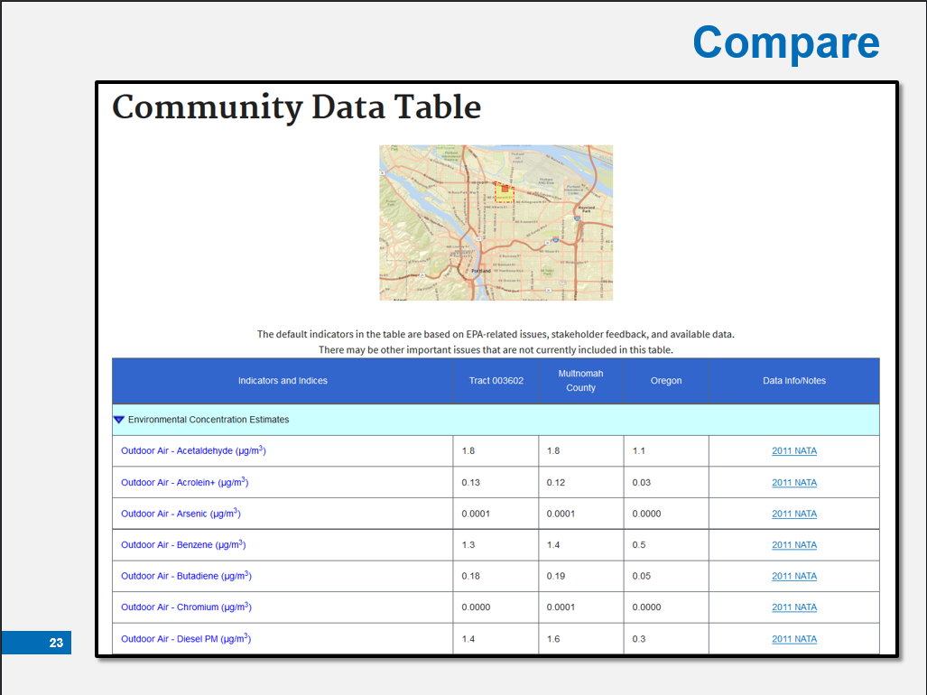 | NATA  U.S. Census (American Community Survey) | The Community Data Table provides a summary of environmental conditions for a community, including estimated concentrations, exposures and risks for select pollutants, as well as demographic information.  Comparing this with information for other geographic areas, such as the county or state, can help to identify environmental conditions that community groups may want to examine further.  Community Data Table data come from the following sources:  -EPA’s 2011 National Air Toxics Assessment (NATA). NATA data is only comparable within a state or nationally. Because of state variations in data generation, it is not comparable across states.  -Demographic indicators are from the 2008-2012 U.S. Census American Community Survey.
Slide 24: Issue Profile  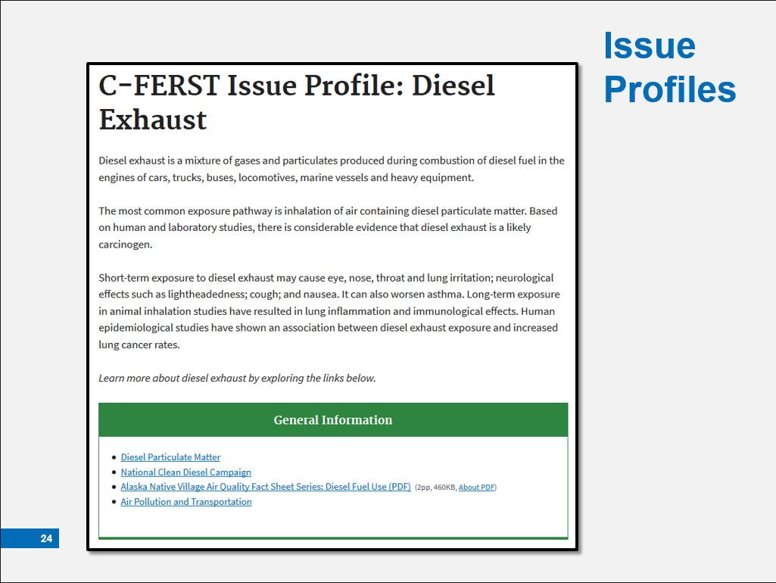 | user-identified concerns  Information from various resources  Includes: General Information, Sources, Environmental Concentrations, Human Exposures, and Health Risks… | The Environmental Issue Profile pulls information from various resources, both inside and outside of EPA, and puts that information into a standardized format, called a profile, for easy reference.  There are Environmental Issues Profiles for user-identified concerns ranging from lead, soil contamination, tobacco smoke and children’s health and asthma to fish consumption, brownfields and diesel PM.  The issue profile also has a built-in mapping function for specific NATA pollutant concentrations, exposures and risks-- searchable by entering a ZIP code or address into the box at the top right of the map. Source allocation pie charts are accessible by clicking on a map location and scrolling down in the pop-up box.  This feature is particularly helpful when assessing and prioritizing specific environmental issues impacting a community.
Slide 25: Issue Profiles  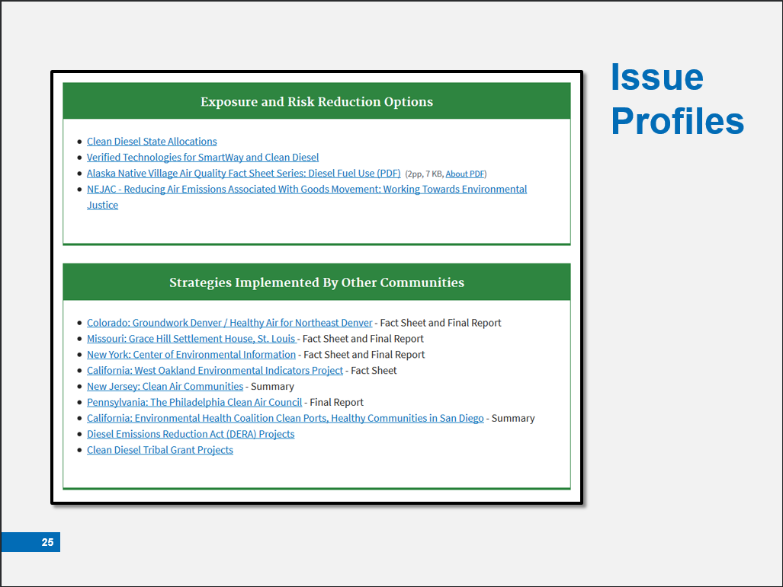 | …and Exposure Reduction Options, and Strategies from Other Communities | The Exposure and Risk Reduction Options & Strategies Implemented by Other Communities sections of the Issue Profiles provide resources to help you consider:  - Potential solutions to your issues such as risk reduction fact sheets  - Projects implemented by other communities  Use these sections to learn what other communities or tribes did to identify, evaluate, and manage their issues.
Slide 26: C-FERST Users  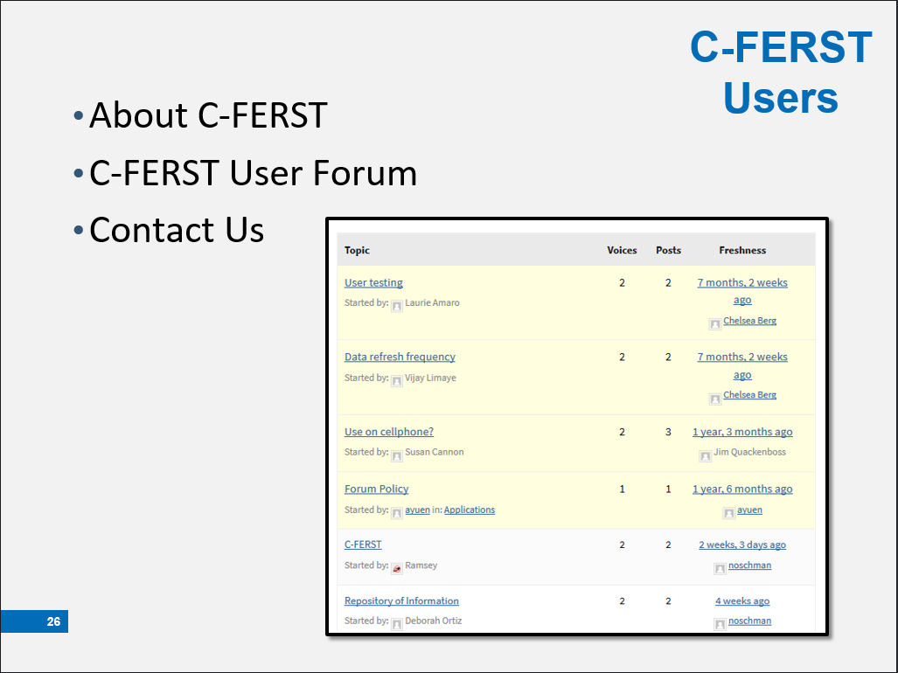 | User Forum for questions and to connect with other users! | The C-FERST Users section contains links and information to help you through the process of learning about C-FERST and also helps you connect with other users.  On the About C-FERST page you can find a questions and answers section, user guides, and explanations of C-FERST features.  The User Forum allows you to post questions or submit answers about C-FERST. This is a great resource to use to interact with or learn from other C-FERST users. It is moderated, so anything you post will not appear instantaneously. Also, the C-FERST team may connect you with other EPA staff and environmental experts to better assist you.  The Contact Us page is accessible at the bottom of any C-FERST page. There, you can find the email and physical mailing address for the C-FERST Team: CFERSTMail@epa.gov. The C-FERST team may put you in touch with the appropriate EPA representative to assist your needs.
Slide 27: Additional Resources  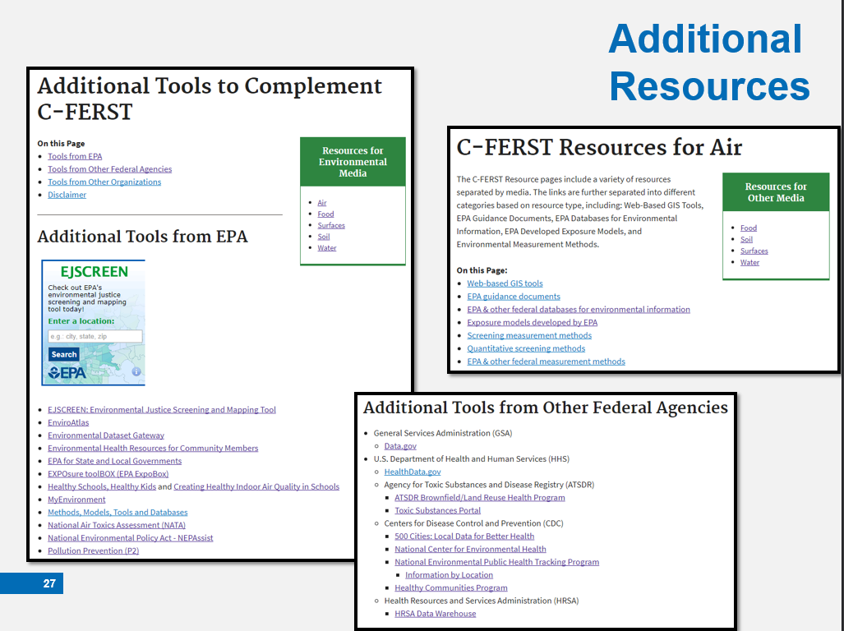 | Additional Resources section includes:  - Additional Tools and Resources  **this includes a link to EPA’s EJ Screening Tool, which complements the information and guides found in C-FERST  - Citizen Science  - Measurement Methods | In the Resources section you will find links to various tools that are available to assist you with C-FERST.  On the Additional Tools page you will find a host of tools and resources that are available to support C-FERST community assessment efforts.  The Citizen Science page includes links to additional tools available for conducting community exposure and cumulative risk assessments. There is also a link to a Blog on citizen science using C-FERST.  The Environmental Measures page contains several types of methods for measuring the level of pollutants in different environments.
Slide 28: C-FERST Data  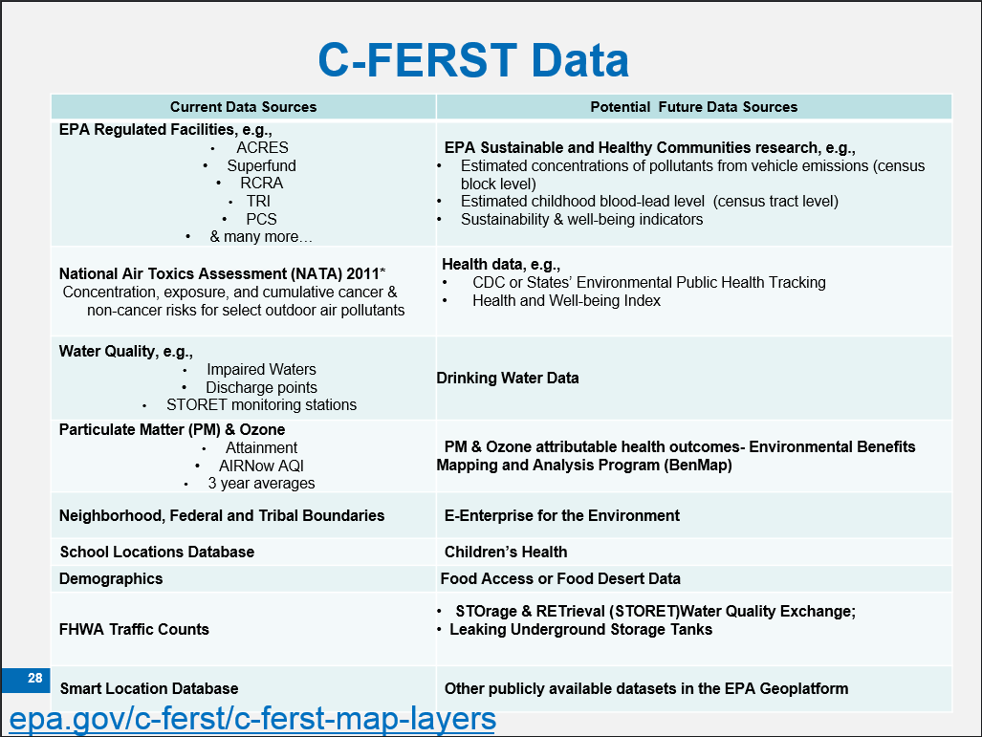 | Current and future data | A complete listing of C-FERST data sources can be found at: https://www.epa.gov/c-ferst/c-ferst-map-layers  C-FERST primarily relies on nationally available data. Since air pollution monitoring data and models are routinely developed at a national level, these data are more complete in C-FERST than data and models for pollutants found in water and soil.  C-FERST does not contain local-scale health outcome information or data on every environmental issue that may be important to a community. C-FERST data should be supplemented with local data and knowledge before taking any action to address potential concerns.  The regulated facilities data may not include other facilities that local agencies or communities could identify and add to C-FERST.  Data on estimated concentration, exposure and risk values for several hazardous air pollutants, as well as estimates of cumulative risks from outdoor air pollutants, found in the Community Data Table are pulled from the following sources:  - Pollutant data are pulled from 2011 National Air Toxics Assessment (NATA)  - Demographic indicators are from the 2008-2012 U.S. Census American Community Survey and are available at the county, state and national level.  The map layers displayed in C-FERST are developed from EPA and other Federal Agency data sources. They are available to the public through EPA’s Environmental Dataset Gateway (EDG) and Data.gov.  For air quality, the data include air toxics, particulate matter (PM) and ozone. For surface water quality, C-FERST includes the STOrage and RETrieval Data Warehouse (STORET) monitoring data.  C-FERST provides links to additional EPA information and allows users to upload additional local data that may be unavailable directly from C-FERST.
Slide 29: Limitations of C-FERST  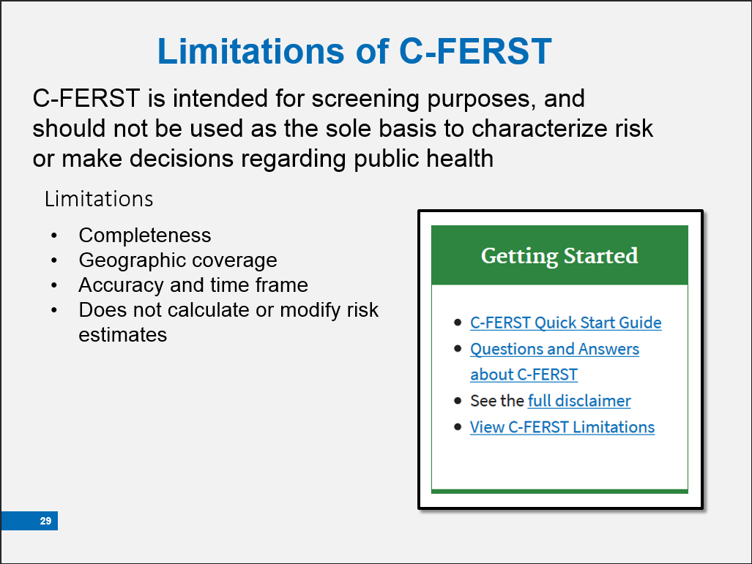 | Completeness - there are other data sources  Geographic coverage – more complete data in urban areas  Accuracy and time frame – it takes time to collect and review data before it’s ready | Like any tool, there are things you can do with it, and there are limitations.  C-FERST is intended for screening purposes and should not be used as the sole basis to characterize risk or make decisions regarding public health.  Communities may need assistance using C-FERST and interpreting the data produced from C-FERST so we encourage you to build partnerships with communities and learn from each other.  Completeness Limitations occur for environmental concentration, exposure and health risk data because C-FERST currently only includes specific national datasets. For example, C-FERST currently does not provide mapping of contaminant concentrations for soils or for drinking water. C-FERST does allow users to upload additional local data that may be unavailable directly from C-FERST. A complete listing of C-FERST data sources can be found here: https://www.epa.gov/c-ferst/limitations-c-ferst  Geographic Limitations occur because national monitoring programs generally occur in more populated areas, there are fewer C-FERST data available in less populated rural or remote areas. This lack of C-FERST data for less populated rural or remote areas does not mean that there may be no contaminant issues for that particular area.  Accuracy and Timeframe Limitations occur because updates or corrections to the EPA or other government data are provided on different schedules. Thus, the data may be old and no longer applicable to the specific location.  For example, it generally takes 3 years to analyze the national air toxics monitoring data and combine it with modeling results to create the National-Scale Air Toxics Assessment (NATA) data that is used in C-FERST.  In regard to other C-FERST data, it is possible for errors to occur in the mapping of facility and monitoring locations due to data entry errors, address changes, and discrepancies in mailing addresses versus physical locations. We advise that important site locations be confirmed. Location discrepancies can be reported to C-FERST for correction by emailing CFERSTMail@epa.gov.  In addition to contacting the C-FERST team, we encourage you to post discrepancies on the User Forum which may encourage other users to add additional discrepancies.
Slide 30: Questions? | Any Questions? | Let's pause for a minute to see if anyone has a question.  If there are no further questions, we will move on to Module 4, the Live Demo!
Slide 31: Module 4: Live Demonstration  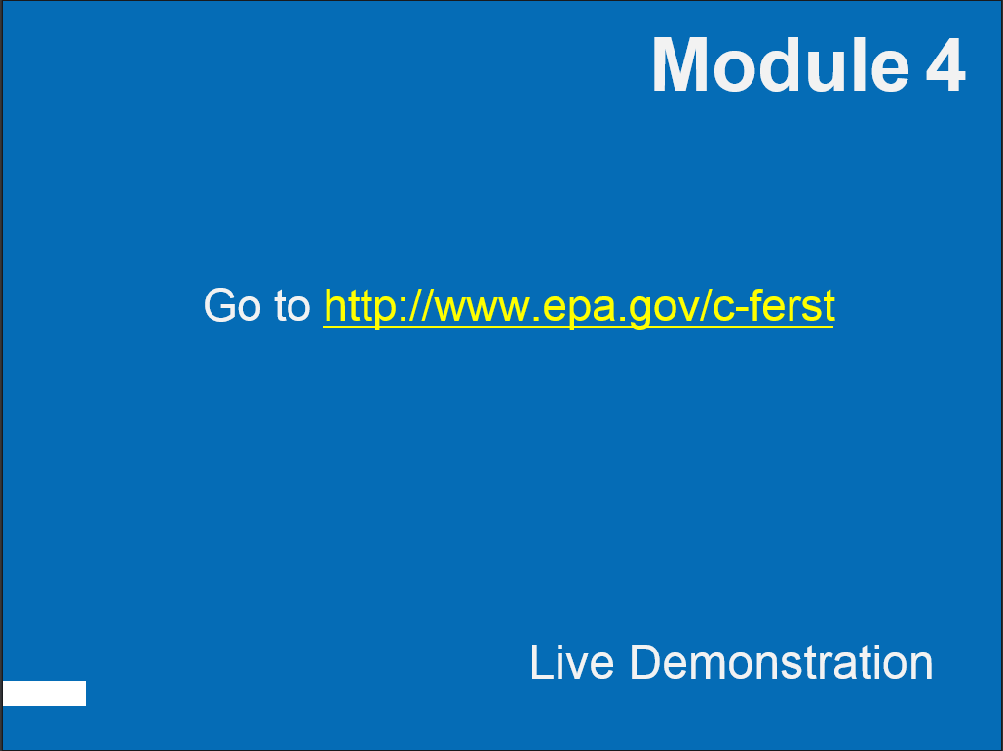 | OPEN C-FERST | Module 4 is a Live Demonstration. Here, we will walk through a community example to show you how to use the tool.  [OPTIONAL: This next line is for those of you presenting to audiences with computers either in person or remotely]  Not only will we show you how to use C-FERST, but you also will be able to use the tool itself by following along on your own computer.  While I transition to C-FERST from this ppt:  - [If you will be demonstrating a participant’s community in the demo portion]  Again, I would like to thank [Participant] for volunteering their community, [community name].  - [If participants are on a webinar or have access to computers with internet]  Please open a browser (like Chrome, Firefox, Internet Explorer, or Edge) and navigate to C-FERST to follow along with me in the demonstration.
Slide 32: Discussion: Presenting C-FERST to Communities  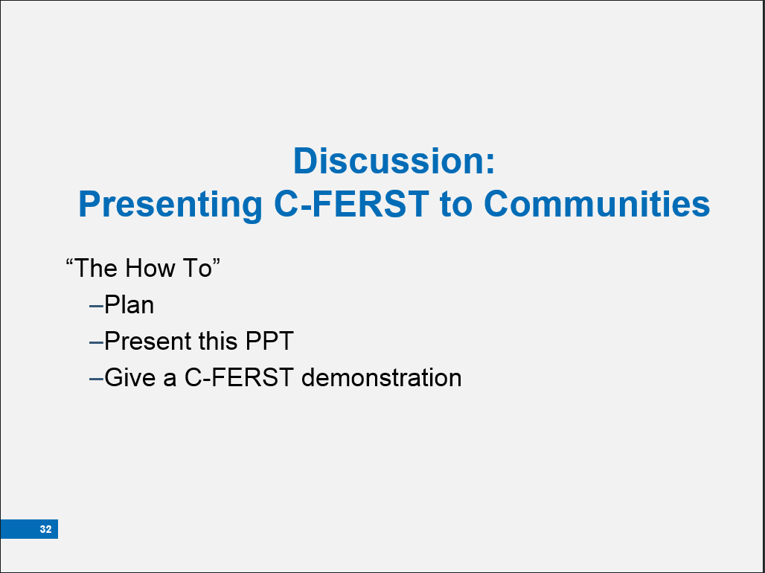 | Does anyone have any questions? | Now that we have walked through the functions of C-FERST, let’s open the discussion about next steps. I (We) would encourage you to download this PPT from the C-FERST website to train people that you know!  For the training today, I (we)  -brainstormed participants  -contacted participants  -found a venue or room or webinar space  -picked a date and time  -sent reminders and instructions  -asked participants if there was a specific community to use for the demo [OPTIONAL]  -downloaded the ppt(s) [One is an example of a live demonstration just in case there is no internet available. You can also use it to get ideas for your demo.]  -practiced  -created a “cheat sheet” for the live demo  Does anyone have any questions?  [Foster discussion by asking if anyone knows of people that may find C-FERST useful in their work or with their community.]
Slide 33: Conclusion  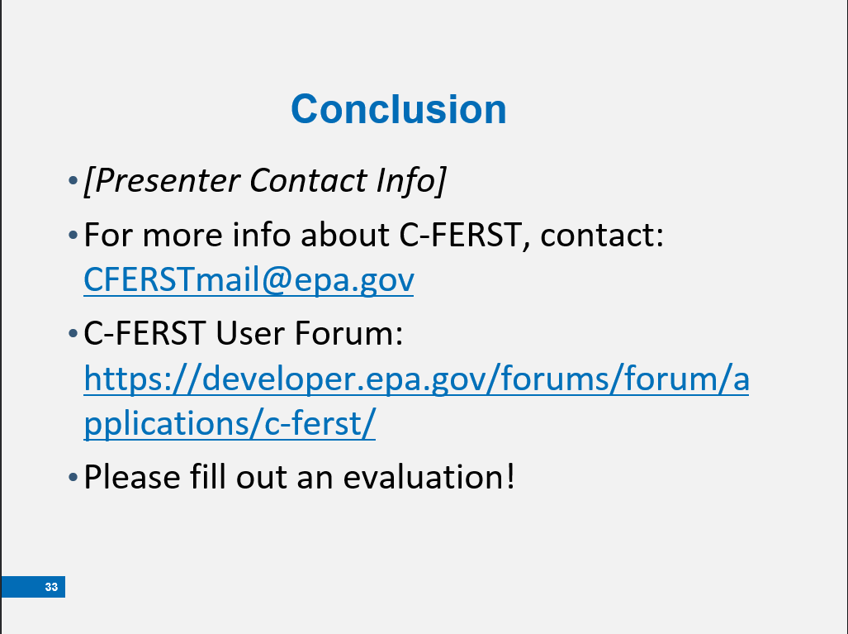 | Thank You! | This concludes our C-FERST Training! Thank you for attending and asking good questions.  My information is found in the first bullet. Please feel free to reach out to me for questions.  [Make sure you remember to edit this presentation and add your information before presenting!]  If you would like more information about C-FERST, please contact the EPA team directly by emailing them at cferstmail@epa.gov. Keep in mind that you will receive a response during working hours.  If you have a question that you think other communities or individuals would find helpful, please enter it on the User Forum, instead.  Before you leave, please fill out an evaluation. Your responses will go into helping make the tool more useful!

