CALIFORNIA RANGELAND

This scenario has been parameterized to represent pesticide application on non-irrigated rangeland in Central California. The area of interest (AOI) is primarily Alameda, Contra Costa, Solano, Sonoma, and Santa Clara Counties. The AOI was selected based on the large extent of rangeland and high degree of pesticide usage (Figure 1). Based on 2005 California pesticide use reporting (CalPIP, 2006), approximately 40% of total product pounds applied to rangelands were applied in the AOI. These counties also accounted for approximately 43% of the total combined acres treated for all pesticides reported.

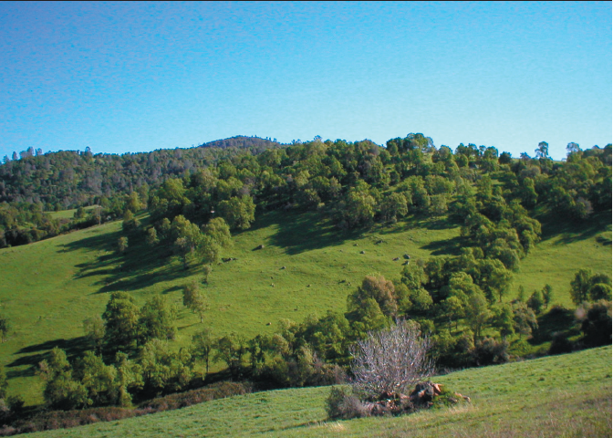
Rangeland in California is extensive; approximately one-third (7.2 million acres) of all privately held lands in California are grazed by livestock (Richards and George, 1996). Rangelands can be grouped into three broad categories: dry annual grasslands, annual grassland/hardwood range, and coastal prairies (Bartalome, 2002). Annual grasslands are dominated by annual grasses and receive less than 12 inches of rainfall per year. Annual grassland/hardwood ranges consist of annual understory grasses, with variable oak and shrub canopy receiving 12-40 inches annual rainfall. Coastal prairies have perennial grasses with variable overstory and variable rainfall. Many of the rangelands present today were cleared in the 1950’s to 1970’s to reduce competition between hardwood species, such as oaks, and understory forage grasses. Since the 1980’s the benefits of tree canopy to provide wildlife habitat has been realized and conservation/regeneration of oak hardwood rangelands has been promoted in rangeland management (IHRMP, 2005). Rangeland in Central California is generally not irrigated (M. Doran, personal communication). However, pastureland in some areas is irrigated. Irrigated pasture is an important source of forage for beef cattle, sheep, horses and dairies. Herbaceous vegetation is generally dominated by cool season grasses (ryegrass, orchard grass, tall fescue) and cool season legumes (ladino clover, strawberry clover, trefoil). Cool season irrigated pasture are most productive in the spring and early summer. Hot weather dampens production as the summer progresses (George et al., 1992). This scenario is not intended to represent irrigated pastureland and application of this scenario to represent irrigated pasture should be evaluated on a case by case basis. In addition, although some range lands contain a significant amount of tree cover, this scenario was parameterized to represent open rangeland in order to model a more conservative field.

Because rangelands occur throughout the state of California (Figure 1), there are over 250 soils listed as supporting irrigated and/or non-irrigated pasture (used here as a surrogate for rangeland production in order to identify representative soils). Soil selection was targeted at the AOI, where the highest pesticide usage has been reported (CalPIP, 2006). Within the AOI, there are approximately 42 soils listed as supporting irrigated and/or non-irrigated pasture (used as a surrogate described above) (Table 5). Among these, Gaviota is the most common pastureland soil; however it was not recommended as a representative rangeland soil by an extension agent in the area of interest. Rather, the agent suggested that Los Osos is a more representative soil of rangelands. Los Osos is the second most common pasture supporting soil in the AOI, is a hydrologic group C soil, and is among the steepest and most erodible soils identified. Within the AOI, the Los Osos series is located in Alameda, Contra Costa, Eastern Santa Clara, and Sonoma Counties. The Los Osos series has a k factor ranging from 0.28 to 0.49 for pastureland supporting soils. Within the Los Osos Series, the Los Osos and Milshom complex has the highest erodibility potential (k factor = 0.49) but not the steepest slope on rangelands (USDA 2005). Because rangelands are found on slopes as steep as 75%, the Los Osos Silty Clay Loam 45-75 percent slopes, was selected on the basis that it is a more conservative soil due to its steep slope. For pesticides that are more influenced by sediment transport, the Los Osos and Millshom soils may be a more conservative selection

Los Osos is a Hydrologic Group C soil. Group C soils represent roughly 41% of pasture supporting soils in the AOI (Table 5). The Los Osos series consists of moderately deep, well drained soils that formed in material weathered from sandstone and shale. Los Osos soils are on uplands and have slopes of 5 to 75 percent (USDA, 2001). The soils are well drained with very high runoff and slow permeability (USDA, 2001). They are used mostly for range; limited areas are cropped to grain and Sudan grass pasture. Vegetation is mostly annual grasses and forbs with some perennial grasses, coastal sagebrush, and live oak. Los Osos soils have an A horizon from 0 to 14 inches (0-36 cm) deep, a B horizon from 14 to 32 inches (36-81 cm) deep, and a C horizon from 32 to 49 inches (81-124 cm) deep. Horizon B however is described as “very hard” with very few roots and pores, therefore drainage is limited (USDA, 2001). Los Osos Silty Clay Loam 45-75 percent slopes was used to parameterize this scenario (USDA 2006).

The AOI lies between the meteorological stations of Sacramento and San Francisco. The Sacramento weather station (W23232) was selected for this scenario because it is roughly within 50 to 100 miles of the counties in the AOI. The station receives approximately 18 inches of rainfall annually. Approximately 60% of the rainfall occurs from January to March (NOAA, 2006).

Table 1. PRZM 3.12 Climate and Time Parameters for Central Coastal California - Rangeland.
Parameter | Value | Source/Comments
Starting Date | Jan. 1, 1961 | Meteorological File from Sacramento, CA (W23232)
Ending Date | Dec. 31, 1990 | Meteorological File from Sacramento, CA (W23232)
Pan Evaporation Factor (PFAC) | 0.75 | PRZM Manual Figure 5.1 (EPA 1998). Value represents midpoint of range for central/coastal California.
Snowmelt Factor (SFAC) | 0.0 | PRZM Manual, Table 5.1 (EPA 1998). San Francisco does not receive snowfall.
Minimum Depth of  Evaporation (ANETD) | 17.5 | Mid point of range (15-20), PRZM Manual, Figure 5.2 (EPA 1998).

Table 2. PRZM 3.12 Erosion and Landscape Parameters for Central Coastal California - Rangeland.
Parameter | Value | Source/Comments
Method to Calculate Erosion (ERFLAG) | 4 (MUSS) | Default value.
USLE K Factor (USLEK) | 0.32 tons EI⁻¹* | NRCS Soil Data Mart Database, Alameda County, for Los Osos silty clay loam, 45-75% slopes. (http://soildatamart.nrcs.usda.gov/).
USLE LS Factor (USLELS) | 25.6 | Calculated according to Haan and Barfield (1978) equation: LS = ((λ/72.6)^{m})((430x² + 30x + 0.43)/6.613), where λ = slope length, x = SLP/100 and m = constant. In this case, λ = 400 m (default value) and m = 0.5 (EPA 2004).
USLE P Factor (USLEP) | 1 | M. Doran, Livestock and Resources Advisor, UCCE. Rangelands are not tilled. No practice factor, no contour plowing is expected (EPA 2004).
Field Area (AFIELD) | 172 ha | Area of Shipman Reservoir watershed (EPA, 1999)
NRCS Hyetograph (IREG) | 2 | PRZM Manual, Figure 5.12 (EPA, 1998).
Slope (SLP) | 37.5 % | M. Doran, Livestock and Resources Advisor, UCCE. Rangelands slopes in the AOI range up to 75%
Hydraulic Length (HL) | 600 m | Shipman Reservoir (PRZM Guidance, EPA, 2004)
Irrigation Flag (IRFLAG) | 0 | Rangelands in the AOI are not generally irrigated (M. Doran, Livestock and Resources Advisor, UCCE.)
* EI = 100 ft-tons * in/ acre*hr

Table 3. PRZM 3.12 Crop Parameters for California – rangeland/hay.
Parameter | Value | Source/Comments
Initial Crop (INICRP) | 1 | Default value
Initial Surface Condition  (ISCOND) | 3 | 3 = Residue. Bartalome, 2002. Recommends 100 to 1800 pounds residual dry matter per acre, depending on slope and woody canopy cover.
Number of Different Crops (NDC) | 1 | Set to number of crops in simulation. Default value.
Number of Cropping Periods (NCPDS) | 30 | Set to weather data in meteorological file Sacramento, CA (W23232)
Maximum rainfall interception storage of crop (CINTCP) | 0.2 | At their maximum growth, grasses may intercept as much as 20% of gross precipitation during individual storms (Dunne and Leopold, 1978).
Maximum Active Root Depth (AMXDR) | 30 cm | M. Doran, Livestock and Resources Advisor, UCCE.  Herbaceous rangeland grasses root as deep as 30cm.
Maximum Canopy Coverage (COVMAX) | 90% | M. Doran, Livestock and Resources Advisor, UCCE.  Canopy cover for rangelands may reach 90% at vegetation maturity.
Soil Surface Condition After Harvest (ICNAH) | 3 | 3 = Residue. Bartalome, 2002. Recommends 100 to 1800 pounds residual dry matter per acre, depending on slope and woody canopy cover.
Date of Crop Emergence  (EMD, EMM, IYREM) | 01/11/60 | M. Doran, Livestock and Resources Advisor, UCCE.  Plants emerge during November, reach peak maturity in April. Grazing (i.e., harvest) occurs from December to May. Emergence set to previous year to ensure mature vegetation during first year of simulation.
Date of Crop Maturity  (MAD, MAM, IYRMAT) | 01/04/61
Date of Crop Harvest  (HAD, HAM, IYRHAR) | 01/05/61
Maximum Dry Weight (WFMAX) | 0.0 | Not used in scenario.
Maximum Canopy Height (HTMAX) | 91 | M. Doran, Livestock and Resources Advisor, UCCE.  Rangeland grasses grow as tall as 36 inches (91 cm). This is true of rangeland and not of irrigated pasture.
SCS Curve Number (CN) | 87, 86, 87 | Gleams Manual Table H-4, pasture/range, non-CNT, hydrologic group C, poor condition (USDA, 2000). No fallow condition. Fallow set to residue value.
Manning's N Value (MNGN) | 0.110 | Sacramento Pasture, cool season (C21PCPCN). This file incorporates no tillage and has a cover code (2) representing first year grass, pasture or hay crops.
USLE C Factor (USLEC) | 0.001 | Sacramento Pasture, cool season (C21PCPCN). This file incorporates no tillage and has a cover code (2) representing first year grass, pasture or hay crops.

Table 4. PRZM 3.12 Los Osos Silty Clay Loam, 45-75% Slopes Soil Parameters for California - rangeland.
Parameter | Value | Source/Comments
Total Soil Depth (CORED) | 76 cm | NRCS Soil Data Mart Database, Los Osos Silty Clay Loam, 45-75% Slopes. (http://soildatamart.nrcs.usda.gov/).  According to extension agent (Morgan Doran), Los Osos is a representative soil type.  The fourth horizon was eliminated because bedrock generally occurs at depths from 18 to 48 inches (USDA, 2006.  PRZM Scenario Guidance (2004).  Adjusted using the relationship % OC = % Organic Matter/1.724 (Doucette 2000).
Number of Horizons (NHORIZ) | 4
Horizon Thickness (THKNS) | 10 cm (HORIZN =1)  10 cm (HORIZN =2)  56 cm (HORIZN =3)
Bulk Density (BD) | 1.25 g/cm3 (HORIZN =1)  1.25 g/cm3 (HORIZN =2)  1.25 g/cm3 (HORIZN =3)
Initial Water Content (THETO) | 0.308 cm3/cm3 (HORIZN =1)  0.308 cm3/cm3 (HORIZN =2)  0.332 cm3/cm3 (HORIZN =3)
Compartment Thickness (DPN) | 0.1 cm (HORIZN =1)  5 cm (HORIZN =2)  4 cm (HORIZN =3)
Field Capacity (THEFC) | 0.308 cm3/cm3 (HORIZN =1)  0.308 cm3/cm3 (HORIZN =2)  0.332 cm3/cm3 (HORIZN =3)
Wilting Point (THEWP) | 0.173 cm3/cm3 (HORIZN =1)  0.173 cm3/cm3 (HORIZN =2)  0.215 cm3/cm3 (HORIZN =3)
Organic Carbon Content (OC) | 1.16 % (HORIZN =1)  1.16 % (HORIZN =2)  0.44 % (HORIZN =3)

Table 5. Pasture Bearing Soils of Alameda, Contra Costa, Solano, Sonoma, and Santa Clara Counties (California) Ranked by Area.
Soil | Total Acreage | % Area | Drainage | Erodibility | Slopes (%) | pH | OM (%) | % Sand | % Silt | % Clay | Pasture (AUM)*
 |  |  |  |  |  |  |  |  |  |  | Irrigated |  | Non-Irr.
GAVIOTA | 106,351.00 | 17.38% | B/D | 0.17-0.37 | 5-75 | 6.3-6.7 | 0.75 | 44.8-66.8 | 19.2-41.2 | 14 | - | 0.75-1
LOS OSOS | 104,241.00 | 17.04% | C | 0.28-0.49 | 30-75 | 5.8-6.5 | 2-3 | 20-35.4 | 33.6-52 | 23.5-31 | - | 0.75-1
ALTAMONT | 75,868.00 | 12.40% | D | 0.2-0.24 | 3-75 | 7.2-7.5 | 1.5-2 | 22.1-23.3 | 27.9-29.2 | 47.5-50 | 12-18 | 1
VALLECITOS | 73,984.00 | 12.09% | D/C | 0.28-0.37 | 15-50 | 6.3-6.5 | 1.5 | 41.6 | 37.4 | 21 | - | 0.75
LOS GATOS | 47,606.00 | 7.78% | C | 0.24-0.37 | 30-75 | 6.1-6.7 | 2.5 | 39.8 | 37.7 | 22.5 | - | 0.75-1
MILLSHOLM | 31,223.00 | 5.10% | D | 0.32-0.55 | 8-50 | 5.8-6.5 | 1.75-2 | 24.5-39.2 | 37.3-52 | 23.5 | - | 1
SAN YSIDRO | 22,229.00 | 3.63% | D | 0.37-0.43 | 0-5 | 5.8-6.1 | 0.75 | 42.1-65.1 | 18.9-37.9 | 16-20 | 15 | -
PESCADERO | 13,918.00 | 2.27% | D | 0.2-0.28 | 0-2 | 5.6-7.3 | 2.5 | 28.1-35.4 | 29.4-33.6 | 31-42.5 | - | 1.5
WRIGHT | 13,615.00 | 2.23% | C | 0.37 | 0-9 | 5.8 | 2.5 | 43 | 39.5 | 17.5 | - | 12
OMNI | 11,468.00 | 1.87% | D | 0.24-0.28 | 0-2 | 7.5-8.8 | 2.5-3.5 | 5.3-34.2 | 31.7-49.8 | 33.5-50 | 10 | 1.5
SOLANO | 10,589.00 | 1.73% | C | 0.37 | 0-2 | 5.3-5.8 | 0.25-1.5 | 44.3-65.4 | 19.6-40.7 | 15 | 12 | -
ARBUCKLE | 8,937.00 | 1.46% | B | 0.32-0.37 | 0-30 | 6.1-6.7 | 0.75 | 43-65.9 | 19.1-38.5 | 15-18.5 | 12 | -
COTATI | 8,612.00 | 1.41% | D | 0.32 | 2-9 | 5.3 | 0.75 | 68.8 | 16.2 | 15 | - | 12
POSITAS | 8,179.00 | 1.34% | D | 0.37 | 20-40 | 5.8 | 1.35 | 42.1 | 37.9 | 20 | - | 0.5
CORNING | 7,375.00 | 1.21% | D | 0.37 | 2-15 | 5.6 | 0.75 | 43 | 39.5 | 17.5 | 12 | -
RED HILL | 7,091.00 | 1.16% | B | 0.28 | 2-75 | 6.1 | 2 | 33.3-35.4 | 31.7-33.6 | 31-35 | - | 1.5
CONEJO | 6,290.00 | 1.03% | C | 0.2-0.24 | 0-5 | 6.7-7 | 2.5 | 35.4-39.2 | 33.6-37.3 | 23.5-31 | 12 | -
SEBASTOPOL | 5,921.00 | 0.97% | B | 0.24 | 2-30 | 5 | 2 | 65.9 | 19.1 | 15 | - | 12
PARRISH | 5,222.00 | 0.85% | C | 0.24-0.32 | 30-50 | 5.8-6.1 | 2-3.5 | 35.4-39.2 | 33.6-37.3 | 23.5-31 | - | 1
BAYWOOD | 4,840.00 | 0.79% | A | 0.15-0.17 | 2-30 | 6.1-6.2 | 2.5 | 80.5-81.1 | 16.4-17 | 2.5 | 10-14 | 2
ALO | 4,720.00 | 0.77% | D | 0.2 | 30-75 | 6.7 | 2 | 23.3 | 29.2 | 47.5 | - | 1
DIABLO | 4,631.00 | 0.76% | D | 0.2 | 30-60 | 7-7.9 | 1.25-1.5 | 23.3-26.1 | 28.9-29.2 | 45-47.5 | - | 0.75
MARCUSE | 4,559.00 | 0.75% | D | 0.2 | 0-2 | 8.5 | 0.75 | 22.1 | 27.9 | 50 | 12 | -
MARVIN | 3,115.00 | 0.51% | C | 0.55 | 0-2 | 7.2 | 1.5 | 26.3 | 52.7 | 21 | 18 | 3
LOS ROBLES | 2,940.00 | 0.48% | B | 0.37 | 0-5 | 7 | 2 | 35.4 | 33.6 | 31 | 16 | -
MANZANITA | 2,473.00 | 0.40% | B | 0.37 | 0-9 | 5.8 | 0.75 | 26.3 | 52.7 | 21 | 11 | -
BOOMER | 2,037.00 | 0.33% | B | 0.37 | 2-30 | 6.1-6.3 | 2 | 39.8 | 37.7 | 22.5 | 12-14 | -
ALVISO | 1,857.00 | 0.30% | D | 0.37 | 0-2 | 7.5 | 0.75 | 16.9 | 48.1 | 35 | 8 | 1
SOBRANTE | 1,779.00 | 0.29% | C/B | 0.37-0.49 | 5-30 | 6.1-6.3 | 2 | 43 | 39.5 | 17.5 | 12 | -
SHEDD | 1,766.00 | 0.29% | C | 0.43 | 30-45 | 8.2 | 1.5 | 9.1 | 64.9 | 26 | - | 1
VALDEZ | 1,587.00 | 0.26% | D | 0.37 | 0-2 | 7.9 | 1.25 | 6.7 | 62.3 | 31 | - | 1
COLE | 1,466.00 | 0.24% | C | 0.32-0.37 | 0-5 | 6.7 | 2.5 | 22.4-35.4 | 33.6-55.1 | 22.5-31 | 10 | -
EGBERT | 1,360.00 | 0.22% | D | 0.24 | 0-2 | 6.5 | 12.5 | 33.3 | 31.7 | 35 | 12 | -
DIBBLE | 1,090.00 | 0.18% | C | 0.37 | 2-9 | 6.1 | 0.75 | 39.2 | 37.3 | 23.5 | 17 | -
MILLSHOLM VARIANT | 766.00 | 0.13% | C | 0.32 | 9-30 | 6.7 | 1.25 | 44.8 | 41.2 | 14 | - | 1
LOBITOS | 761.00 | 0.12% | C | 0.28 | 9-45 | 5.3 | 2 | 41.6 | 37.4 | 21 | - | 0.75
AZULE | 546.00 | 0.09% | C | 0.28 | 30-50 | 6.3-6.5 | 1.5 | 35.4 | 33.6 | 31 | - | 1
SAN ANDREAS | 441.00 | 0.07% | C | 0.15 | 15-30 | 5.8 | 2.5 | 66.9 | 20.1 | 13 | 20 | -
CLIMARA | 370.00 | 0.06% | D | 0.2 | 30-50 | 7.5 | 1.5 | 22.1 | 27.9 | 50 | - | 1
BIGRIVER | 29.00 | 0.00% | B | 0.2 | 0-5 | 6.1 | 2 | 83.5 | 9 | 7.5 | 15 | 8
REIFF | 2.00 | 0.00% | B | 0.37 | 0-2 | 7 | 1.5 | 40 | 47 | 13 | 12 | -
COOMBS | 1.00 | 0.00% | B | 0.37 | 2-5 | 5.6 | 0.75 | 39.2 | 37.3 | 23.5 | 13 | -
*AUM = Animal Units Per Month. AUM equals the amount of forage necessary to feed one cow and her calf for one month

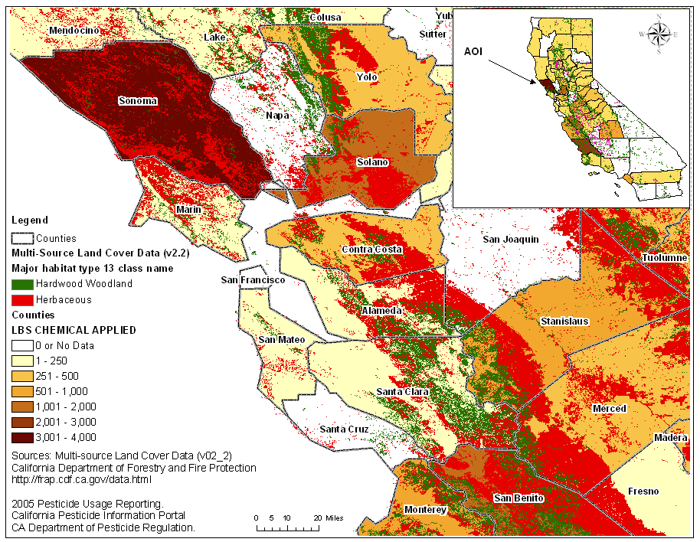
Figure 1. California Hardwood and Herbaceous Areas in the AOI and 2005 Pesticide Usage (Pounds of Chemical Applied) by County.

Sensitive Parameter Uncertainties

Metfile

The San Francisco weather station (W23234) was selected for this scenario because it is within roughly 50 to 100 miles of the counties in the AOI. There are is some uncertainty with the meteorology in that rangelands occur at a wide range of elevations through the state. Based on the Official Soil Series Description for Los Osos soils (used for this scenario), the soils are found at elevations of 100 to 3,500 feet and mean annual precipitation is 14 to 40 inches (USDA, 2001). In contrast, the majority of the California stations containing data for PRZM at elevations below 100 meters and observe less than 25 inches of rainfall per year. The PRZM metstation with the highest elevation in California is in Eureka located in the Northwestern corner of the state where little range land exists and pesticide are not frequently applied (Figure 1). Based on this information, San Francisco is the most conservative and representative station available.

Crop Parameters

As discussed above, rangeland vegetation is a heterogeneous mixture of trees and grasses. For the purposes of modeling, it was necessary to select crop specific parameters (Table 3) that are representative of rangeland plants. In order to model areas that would be more likely to be subject to pesticide applications and susceptible to runoff, grassy areas were selected for the conceptual model of this scenario, rather than tree areas. This decision was necessary for the selection of several sensitive parameters, including CN, USLEC and Manning’s n values.

USLE LS Factor

The scenario USLELS value was calculated with the Haan and Barfield equation (1978) using a 75% slope and an assumed 400-foot slope length, as per PRZM scenario development guidance (EPA, 2001). LS values for slopes longer than 300 feet or steeper than 18% are extrapolations beyond the research data range, however, which increases uncertainty in them. A 75% slope combined with a 400-foot slope length is so far past the research data range that the uncertainty in the calculated value is very great.

Contacts

Mr. Morgan Doran
Livestock & Natural Resources Advisor
University of California Cooperative Extension
Napa, Solano, Yolo and Sacramento Counties
501 Texas Street
Fairfield, CA 94533
Phone: 707.784.1326
Fax: 707.429.5532
mpdoran@ucdavis.edu

References

Bartolome J.W., W.E. Frost, N.K. McDougald and J.M. Connor. 2002. California Guidelines for Residual Dry Matter (RDM) Management on Coastal and Foothill Annual Rangelands. Rangeland Monitoring Series, University of California Ag and Nat Res Pub 8092. Oakland, CA. 8 p. Available online: http://californiarangeland.ucdavis.edu/Publications%20pdf/8092.pdf

CalPIP. 2006. 2005 Pesticide Usage Reporting. California Pesticide Information Portal, CA Department of Pesticide Regulation. Accessed December 4, 2006. Online at: http://calpip.cdpr.ca.gov/cfdocs/calpip/prod/main.cfm
Dunne, T., and L. Leopold. 1978. Water in Environmental Planning. W.H. Freeman an Company, New York. 818 pp.
EPA. 1998. Carsel, R.F., J.C. Imhoff, P.R. Hummel, J.M. Cheplick, and A.S. Donigian, Jr. PRZM-3, A Model for Predicting Pesticide and Nitrogen Fate in the Crop Root and Unsaturated Soil Zones: Users Manual for Release 3.0. National Exposure Research Laboratory, Office of Research and Development, U.S. Environmental Protection Agency, Athens, GA.
EPA. 2004. Pesticide Root Zone Model (PRZM) Field and Orchard Crop Scenarios: Guidance for Selecting Field Crop and Orchard Scenario Input Parameters. November 15, 2001; Revisions July 2004.
George, M.R., Sands, P.B., Wilson, C.B., Ingram, R., and J.M. Connor. 1992. Irrigated warm- and cool-season grasses compared in Northern California pastures. Cal. Agr. July-August:21-25. Available online: http://californiarangeland.ucdavis.edu/Publications pdf/irrigwarmcoolgrasscompare.pdf
Haan, C.T. and B.J. Barfield. 1978. Hydrology and Sedimentology of Surface Mined Lands. Office of Continuing Education and Extension, College of Engineering, University of Kentucky, Lexington, Kentucky 40506. 286 p.
IHRMP. 2005. 2005 Annual Report of the Integrated Hardwood Range Management Program. University of California, Division of Agriculture and Natural Resources. Available online: http://nature.berkeley.edu/forestry/pdfs/ihrmpannualpress.pdf
Richards, R.T. and M.R. George. 1996. Evaluating Changes in Ranch Management Practices through Extension Education. J. Range Manage. 49:76-80.
NOAA. 2006. Climate Normals at Major Weather Observing Stations in all 50 States, Puerto Rico, and Pacific Islands. National Oceanic and Atmospheric Administration (NOAA), Environmental Satellite, Data, and Information Service. Online at: http://www1.ncdc.noaa.gov/pub/data/ccd-data.
USDA. 2000. Knisel, W.G., and Davis, F.M., 2000, GLEAMS: Groundwater Loading Effects of Agricultural Management Systems, Version 3.0: Agricultural Research Service, U.S. Department of Agriculture, Publication No. SEWRL-WGK/FMD-050199, 191 p.
USDA. 2001. Official Series Description LOS OSOS Series. Information from the website: http://ortho.ftw.nrcs.usda.gov/osd/dat/L/LOS OSOS.htm.
USDA. 2006. Soil Survey Areas of Alameda, Contra Costa, Solano, Sonoma, and Santa Clara Counties, California. U.S. Department of Agriculture, Natural Resources Conservation Service (NRCS), Soil Data Mart. March 1, 2006. Online at: http://soildatamart.nrcs.usda.gov.

